Name: ______________________________

The purpose of this project is to allow you to explore a current events topic of your choice. You will identify what the crux of your issue is, what the historical thinking has been around the issue and what the different viewpoints are on the topics today. In the process of doing this, you will be practicing your research and writing skills, as well as becoming more of an “expert” on an issue that you feel passionately about.

Step 1: Picking a topic
- Go to http://bhslibrary.weebly.com/ and click on “Online Databases” on the left-hand bar. Then, click on “Opposing Viewpoints in Context”

- Spend a few minutes exploring the different options in terms of issues. There are more options than simply what appear on the main page. For example, if you are interested in “Law and Politics” you would click on “View All” where you will find over 100 more specific topics. Pick ONE to focus on. (There are SO many choices- pick something that you really care about.)

- Topic: _____________________________________________

Step 2: Background and Historical Information
1) Click on the topic of your choice. This will bring you to a page that will have links to ALL of the information you need. Read the main article on that page by clicking “View More.”
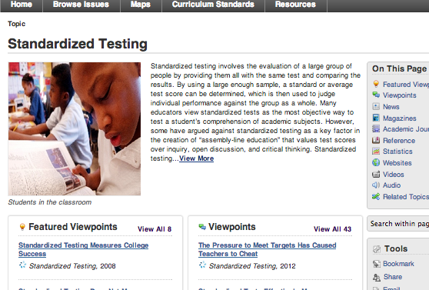

CLICK

Take notes on what your topic is all about. For example, if your topic is “Standardized Testing,” you would find quotes and summarize in bullet form what this sort of testing is, why it is used, and why it is controversial. If your topic was “Juvenile Drug Abuse” you would explain why teens may use drugs, what effects drugs have on teens, how wide-spread the problem is, etc. USE THE TITLES IN THE ARTICLE TO FIGURE OUT WHAT IS NECESSARY TO TAKE NOTES ON… EVERY TOPIC IS DIFFERENT.

________________________________________________________________________________________________________________________________________________________________________________________________________________________________________________________________________________________________________________________________________________________________________________________________________________________________________________________________________________________________________________________________________________________________________________________________________________________________________________________________________________________________________________________________________________________________________________________________________________________________________________________________________________________________________________________________________________________________________________________________
________________________________________________________________________________________________________________________________________________________________________________________________________________________________________________________________________________________________________________________________________________________________________________________________________________________________________________________________________________________________________________________________________________________________________________________________________________________________________________________________________________________________________________________________________________________________________________________________________________________________________________________________________________________________________________________________________________________________________________________________
________________________________________________________________________________________________________________________________________________________________________________________________________________________________________________________________________________________________________________________________________________________________________________________________________________________________________________________________________________________________________________________________________________________________________________________________________________________________________________________________________________________________________________________________________________________________________________________________________________________________________________________________________________________________________________________________________________________________________________________________

Historical Context:
What does your article say about the history of this issue? Find quotes or summarize your findings!
________________________________________________________________________________________________________________________________________________________________________________________________________________________________________________________________________________________________________________________________________________________________________________________________________________________________________________________________________________________________________________________________________________________________________________________________________________________________________________________________________________________________________________________________________________________________________________________________________________________________________________________________________________________________________________________________________________________________________________________________
________________________________________________________________________________________________________________________________________________________________________________________________________________________________________________________________________________________________________________________________________________________________________________________________

Scroll down to the bottom your article and COPY the citation. You will get NO credit for any of your work if you do not cite your sources.

Example:
"Juvenile Drug Abuse." Current Issues: Macmillan Social Science Library. Detroit: Gale, 2010. Opposing Viewpoints In Context. Web. 3 Mar. 2013.

________________________________________________________________________________________________________________________________________________________________________________________________________________________________________________________________________________________________

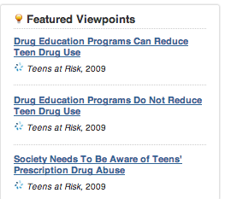
Step 3: Featured Viewpoints
Return to the main page for your topic. You should see a box entitled “Featured Viewpoints.” The first two links represent opposing views around some aspect of your issue. For example, if you are researching “Juvenile Drug Abuse” the different opinions are about whether drug education programs are effective.

Both sides of the issue have guiding questions to help you identify key information as you read the article. Write down the questions for both articles and answer them as you read.

Example: Article ONE title: Drug Education Programs Can Reduce Teen Drug Use
Question 1: According to the viewpoint, who teaches the D.A.R.E. program in the schools?

Article ONE title: ________________________________________________________________________________
Source Citation: ________________________________________________________________________________
________________________________________________________________________________________________________________________________________________________________________________________________

Question 1: _____________________________________________________________________________________
________________________________________________________________________________________________________________________________________________________________________________________________
Answer 1:

Question 2: _____________________________________________________________________________________
________________________________________________________________________________________________________________________________________________________________________________________________
Answer 2:

Question 3: _____________________________________________________________________________________
________________________________________________________________________________________________________________________________________________________________________________________________
Answer 3:

Article TWO title: ________________________________________________________________________________
Source Citation: ________________________________________________________________________________
________________________________________________________________________________________________________________________________________________________________________________________________

Question 1: _____________________________________________________________________________________
________________________________________________________________________________________________________________________________________________________________________________________________
Answer 1:

Question 2: _____________________________________________________________________________________
________________________________________________________________________________________________________________________________________________________________________________________________
Answer 2:

Question 3: _____________________________________________________________________________________
________________________________________________________________________________________________________________________________________________________________________________________________
Answer 3:

Write quotes or summarize the different sides of your issue. Your should have 5-6 points on each side.
For example:
Drug ed. programs reduce teen drug use | Drug ed. Programs do not reduce teen drug use
- Many teens see using drugs as part of the social scene and view the drug education they received in elementary school as “exaggerations or even falsehoods once teenagers acquire first-hand knowledge.”  Effective drug education needs to involve teens in determining the topic of discussion and allow teens the freedom to ask questions. Teens do not respond well to “indoctrination.” | - A Kentucky study of sixth graders found “no difference in the past-year use of cigarettes, alcohol, or marijuana among D.A.R.E. graduates and non-graduates.”

Set up and complete the following chart based on your issue:
Personal Response:
Now that you have completed all of your research you should be an “expert” on your issue. Your job is to argue your OWN opinion about the topic, using the information you collected.

First paragraph: Explain what your issue is. You should pull quotes from your Background and Historical Context sections of your notes. Your paragraph should be about 8-10 sentences. Make sure to cite any quotes that you use. You can do this by putting the author or title and date in parenthesis at the end of your paragraph. Ex) (Juvenile Drug Abuse, 2010).

Second and third Paragraphs: You should write two paragraphs (of 6-8) sentences each in which you argue your opinion on the topic. You should pull quotes from BOTH of your Featured Viewpoints, justifying your opinions and explaining why you take issue with others. Use parenthetical citations at the end of your paragraphs.

While this is a response paper, and not a formal MEATEAL essay, you should still be using evidence and explaining it.

Please remember that your “opinion” should not be pure agreement with one side or the other, but show that you HAVE REALLY THOUGHT about both sides and come to your own conclusion!

*You may handwrite OR type this
________________________________________________________________________________________________________________________________________________________________________________________________________________________________________________________________________________________________________________________________________________________________________________________________________________________________________________________________________________________________________________________________________________________________________________________________________________________________________________________________________________________________________________________________________________________________________________________________________________________________________________________________________________________________________________________________________________________________________________________________
________________________________________________________________________________________________________________________________________________________________________________________________________________________________________________________________________________________________________________________________________________________________________________________________________________________________________________________________________________________________________________________________________________________________________________________________________________________________________________________________________________________________________________________________________________________________________________________________________________________________________________________________________________________________________________________________________________________________________________________________
________________________________________________________________________________________________________________________________________________________________________________________________________________________________________________________________________________________________________________________________________________________________________________________________________________________________________________________________________________________________________________________________________________________________________________________________________________________________________________________________________________________________________________________________________________________________________________________________________________________________________________________________________________________________________________________________________________________________________________________________
________________________________________________________________________________________________________________________________________________________________________________________________________________________________________________________________________________________________________________________________________________________________________________________________________________________________________________________________________________________________________________________________________________________________________________________________________________________________________________________________________________________________________________________________________________________________________________________________________________________________________________________________________________________________________________________________________________________________________________________________
________________________________________________________________________________________________________________________________________________________________________________________________________________________________________________________________________________________________________________________________________________________________________________________________________________________________________________________________________________________________________________________________________________________________________________________________________________________________________________________________________________________________________________________________________________________________________________________________________________________________________________________________________________________________________________________________________________________________________________________________
________________________________________________________________________________________________________________________________________________________________________________________________________________________________________________________________________________________________________________________________________________________________________________________________________________________________________________________________________________________________

