NOODLE TOOLS: HOW TO CREATE A CITATION AND NOTECARD
Instructions/Sample

For this project, we will use NoodleTools to record/organize your research on notecards, generate a bibliography, and create an outline. NoodleTools will be a valuable resource to us, as it will enable me to contact with you in real-time, and comment directly on your notecards and source cards.

STEP ONE: CREATE PROJECT

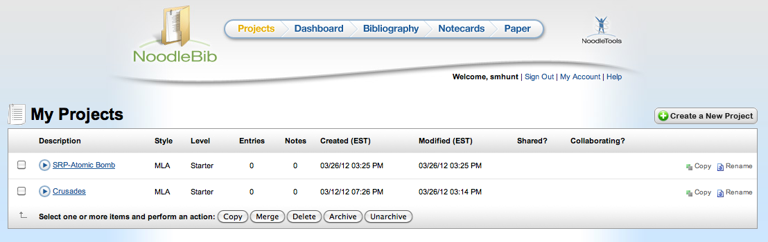

Please do not label your project, “Research Paper,” as it will make it difficult for me to distinguish one project from another. Please label your project as follows, “SRP- [Your name]” or “SRP – [Your topic]”

STEP TWO: SHARE YOUR PROJECT WITH ME

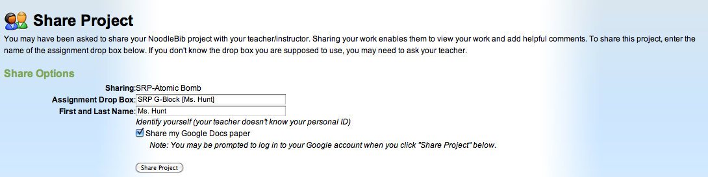

After you have created your project, you will see the option to share the project with me. The Assignment Drop Box is “SRP C-Block [Ms. Hunt].” You will then write your first and last name below.

STEP THREE: CREATING A CITATION

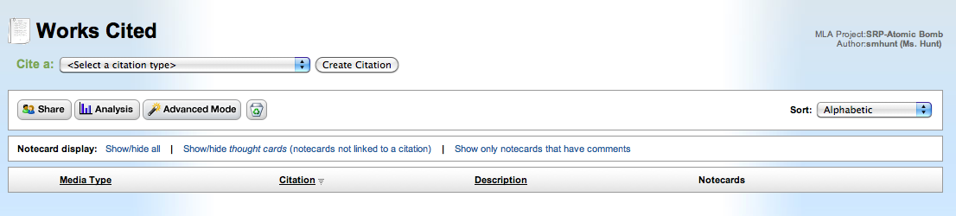
This is very important: Before you begin adding notecards, you MUST create a citation for the source. This will allow you to connect all of your notecards to their specific sources.

Once you are on your project page, click “Bibliography.” You will then need to select your citation type from the drop down menu and click “Create Citation.”

Here is citation information from an article I found on World History in Context:

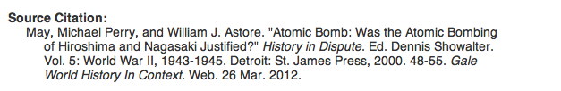

Articles found on the online databases will usually have the citation information at the end of the article. Remember to scroll down and check – it will save you time!

You will then use the information found under “Source Citation” to fill in the needed fields on Noodle Tools. See sample below:

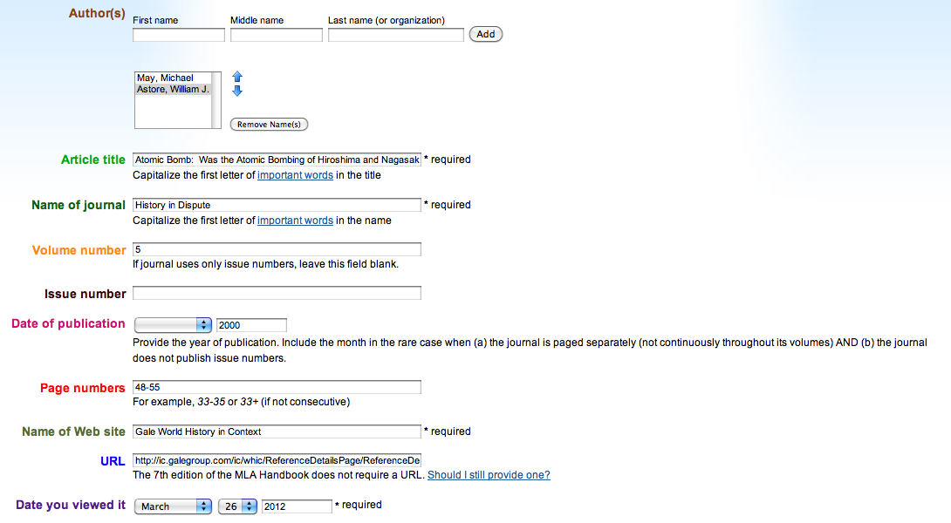

STEP FOUR: CREATING NOTECARDS
After you create a citation, you should automatically be redirected to your bibliography, and your citation should appear. Now you are ready to create notecards for the information you have found in that source!

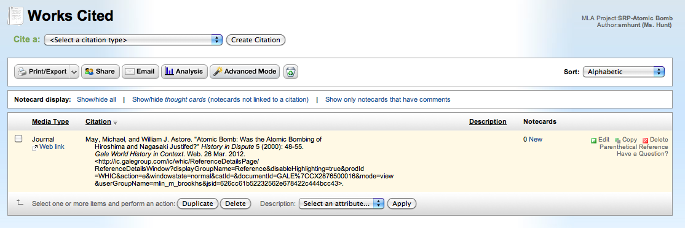

Click “New” next to your citation. You do not have to add all of your notecards now. You can go back throughout the process and add more.

Below, I have included a sample notecard from the source I found on the Atomic Bomb. You must complete each of the steps below for every notecard you create.

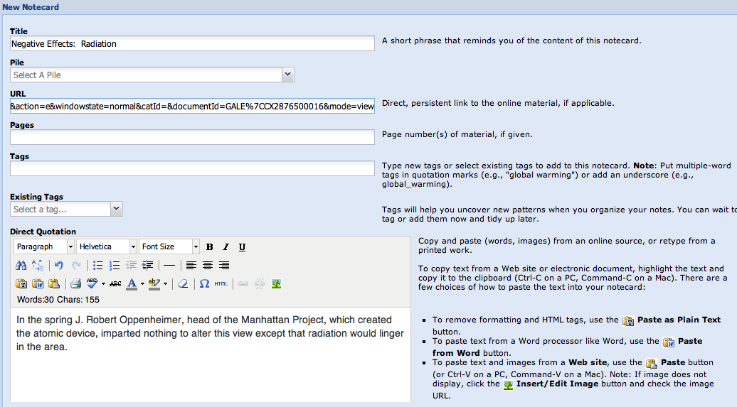

Title the notecard with a phrase or word that describes the general theme of the notecard, and one that makes sense to you. Then, copy and paste the URL straight from the address box.

You will then copy and paste the information you are thinking about including in your paper into the “Direct Quotation” box. You should have no more than 3 sentences worth of information per notecard.

After you copy and paste the desired information, you must paraphrase (put in your own words) it. See next page.

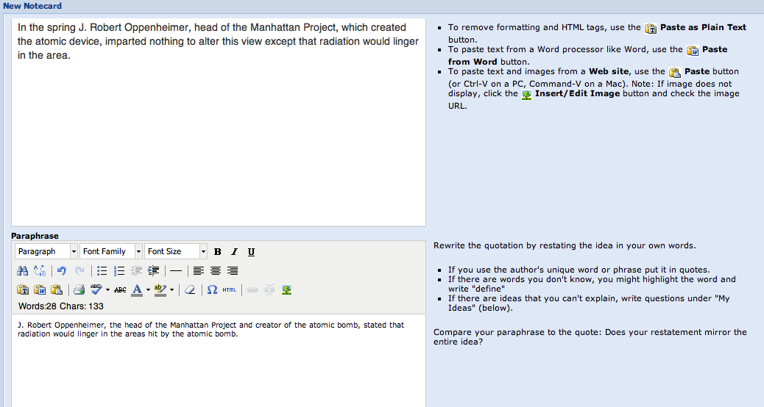

You must paraphrase each of your notecards. Most of the information you cite in your paper will NOT be in quotations, but be paraphrased facts.

After you paraphrase your notecard, you will make a note to yourself in the “My Ideas” section. In this section, write where you think this information will fit in your paper. If you cannot come up with anything, maybe this notecard will not be of use to you!

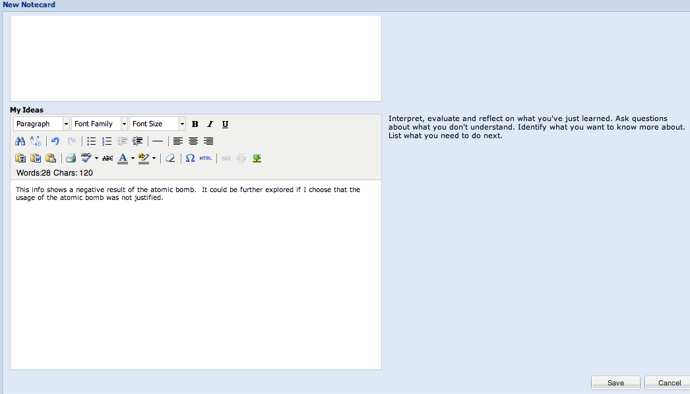

After you have finished your notecard, be sure to click “Save.” You will then be redirected to your bibliography page, where you should see your notecard.

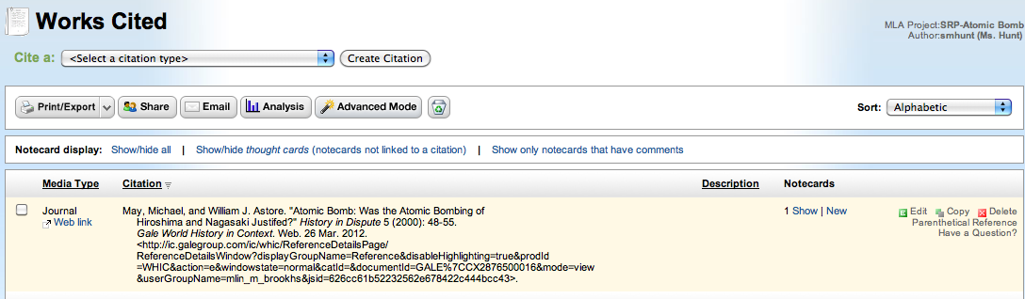

If you have any questions, please come see me!

GOOD LUCK!

